

**DJS Fitness**

**Introduction to DJS Fitness:**

DJS Fitness is the overall state of health and well-being achieved through regular physical activity, proper nutrition, and balanced lifestyle habits. It is not only about building strength or losing weight, but also about improving endurance, flexibility, mental health, and energy levels. Personal fitness helps individuals develop a healthier body, reduce the risk of lifestyle-related diseases, manage stress, and enhance daily performance**.**

**Maintaining DJS Fitness requires a combination of:**

* **Exercise** (cardio, strength training, flexibility exercises, etc.)
* **Healthy diet** (balanced intake of nutrients, vitamins, and hydration)
* **Rest & recovery** (adequate sleep and relaxation)
* **Consistency & discipline** (regular practice and motivation)

In short, DJS Fitness empowers individuals to take control of their physical and mental well-being, leading to a more active, productive, and fulfilling life.



**Importance of DJS Fitness:**

DJS Fitness plays a vital role in improving the quality of life. Regular exercise strengthens the muscles, heart, and lungs, improves stamina, and boosts immunity. It also helps in controlling weight, preventing lifestyle diseases such as diabetes, obesity, and heart problems. Moreover, personal fitness is directly linked to mental health, as exercise reduces stress, improves mood, and increases self-confidence.



DJS Fitness is not limited to looking good or building muscles. It plays a vital role in preventing lifestyle diseases such as obesity, diabetes, and heart problems. Regular exercise strengthens the body, increases stamina, improves flexibility, and boosts immunity. At the same time, it helps reduce stress and anxiety, making us more productive and confident.

**Components of DJS Fitness:**

1. **Physical Exercise** – Activities like running, cycling, yoga, and gym workouts improve strength and endurance.
2. **Balanced Diet** – Nutritious food provides the body with energy, vitamins, and minerals needed for growth and repair.
3. **Rest and Recovery** – Proper sleep and relaxation help the body and mind recharge.
4. **Consistency** – Following a regular routine is key to achieving long-term fitness.

**Consistency and Lifestyle:**

DJS Fitness is a continuous process, not a short-term goal. Simple habits like walking, cycling, practicing yoga, and choosing healthy food can make a big difference. Discipline, consistency, and motivation are the keys to long-term fitness success.

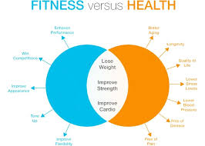

**Ways to Maintain DJS Fitness:**

* Engage in daily physical activity.
* Eat a healthy, balanced diet and stay hydrated.
* Avoid unhealthy habits such as smoking and junk food.
* Get enough sleep and manage stress through meditation or hobbies.

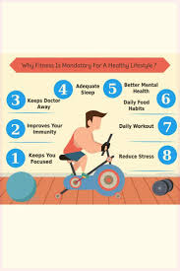

DJS Fitness is the foundation of a healthy and happy life. It is not a one-time goal but a continuous journey that requires discipline, dedication, and consistency. By focusing on exercise, nutrition, rest, and positive habits, individuals can enjoy a more energetic, productive, and fulfilling life.

**Role of Nutrition and Rest:**

A healthy body requires a balanced diet rich in proteins, vitamins, minerals, and water. Good nutrition fuels the body for exercise and daily activities, while rest and sleep are equally important to allow recovery and growth. Without proper rest, even the best workout or diet will not be effective.

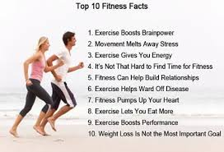

**Conclusion**

In conclusion, DJS Fitness is the foundation of a healthy and happy life. It improves physical strength, mental peace, and emotional stability. Everyone should make fitness a daily priority to live not just longer, but also better and more fulfilling lives.

